## 

## “NUMBER PLATE RECOGNITION USING MATLAB”

**A MINI PROJECT**

**REPORT**

***Submitted by***

**B.Bharath Sai (1NH18EC129)**

**S.Vamsi Krishna Reddy (1NH18EC743)**

**A.Naga Seshu (1NH18EC704)**

**J.Chandana (1NH18EC719)**

***In partial fulfillment for the award of the degree of***

**BACHELOR OF ENGINEERING**

**IN**

**ELECTRONICS AND COMMUNICATION ENGINEERING**



## DEPARTMENT OF ELECTRONICS AND COMMUNICATION ENGINEERING

**CERTIFICATE**

Certified that the mini project work entitled “**NUMBER PLATE RECOGNITION USING MATLAB**” carried out by**, B.BharathSai(1NH18EC129) , S.Vamsi Krishna Reddy(1NH18EC743) ,A.Naga Seshu (1NH18EC704) , J.Chandana (1NH18EC719)** bonafide student of Electronics and Communication Department, New Horizon College of Engineering, Bangalore.

The mini project report has been approved as it satisfies the academic requirements in respect of mini project work prescribed for the said degree.

Project Guide HOD ECE

(Dr. A. B. Gurulakshmi) (Dr. Sanjeev Sharma)

------------------------- -------------------------

**External Viva**

Name of Examiner Signature with Date

1.

2.

**ACKNOWLEDGEMENT**

The satisfaction that accompany the successful completion of any task would be, but impossible without the mention of the people who made it possible, whose constant guidance and encouragement helped us succeed.

We thank **Dr. Mohan Manghnani**, Chairman of **New Horizon Educational Institution**, for providing necessary infrastructure and creating good environment.

We also record here the constant encouragement and facilities extended to us by **Dr.Manjunatha**, Principal, NHCE and **Dr. Sanjeev Sharma**, head of the department of Electronics and Communication Engineering. We extend sincere gratitude to them.

We sincerely acknowledge the encouragement, timely help and guidance to us by our beloved guide **Dr. A B Guru Lakshmi** to complete the project within stipulated time successfully.

Finally, a note of thanks to the teaching and non-teaching staff of electronics and communication department for their co-operation extended to us, who helped us directly or indirectly in this successful completion of mini project.

**B.Bharath Sai (1NH18EC129)**

**S.Vamsi Krishna Reddy (1NH18EC743)**

**A.Naga Seshu (1NH18EC704)**

**J.Chandana (1NH18EC719)**

**TABLE OF CONTENTS**

ABSTRACT

**CHAPTER 1**

INTRODUCTION…………………………………………………………………………………7

**CHAPTER 2**

LITERATURE SURVEY………………………………………………………………………… 9

**CHAPTER 3**

EXISTING SYSTEM AND PROBLEM STATEMENT………………………………….12

**CHAPTER 4**

PROPOSED METHODOLOGY…………………………………………………………………..19

**CHAPTER 5**

PROJECT DESCRIPTION ………………………………………………………………………..21

**CHAPTER 6**

RESULTS AND DISCUSSION…………………………………………………………………37

**CHAPTER 7**

CONCLUSION AND FUTURE SCOPE …………………………………………………………38

REFERENCES…………………………………………………………………………………….40

**LIST OF FIGURES**

|  |  |  |
| --- | --- | --- |
| **FIGURE**  **No** | **FIGURE DESCRIPTION** | **Page**  **No** |
| 4.1 | Block diagram | 19 |
| 5.1 | MATLAB desktop environment | 23 |
| 5.2 | Current folder | 24 |
| 5.3 | Command window | 24 |
| 5.4 | Workspace | 25 |
| 5.5 | Command history | 25 |
| 5.6 | RGB image | 31 |
| 5.7 | Grayscale imge | 31 |
| 5.8 | Binarized image with sobel edge detection | 32 |
| 5.9 | Dilated image | 33 |
| 5.10 | Filled image | 33 |
| 5.11 | Image with connected borders | 34 |
| 5.12 | Extracted number plate region | 34 |
| 5.13 | Number plate | 35 |
| 5.14 | Segmented image | 35 |
| 5.15 | Binary images of alpha numbers | 36 |
| 6.1 | Result | 37 |

### LIST OF TABLES

|  |  |  |  |
| --- | --- | --- | --- |
| **SL**  **No** | **Table**  **No** | **TABLE DESCRIPTION** | **Page**  **No** |
| 1 | 2.1 | Literature review | 9 |
| 2 | 5.1 | MATLAB used operators | 32 |
| 3 | 5.2 | Commands for managing a session | 27 |
| 4 | 5.3 | Input and output commands | 28 |

**ABSTRACT**

The VPR (Vehicle Number plate Recognition) system is based on image processing technology. It is one of the necessary systems designed to detect the vehicle number plate. In today’s world with the increasing number of vehicle day by day it’s not possible to manually keep a record of the entire vehicle. With the development of this system it becomes easy to keep a record and use it whenever required. The main objective here is to design an efficient automatic vehicle identification system by using vehicle number plate. The system first would capture the vehicles image as soon as the vehicle reaches the security checking area. The captured images are then extracted by using the segmentation process. Optical character recognition is used to identify the characters. The obtained data is then compared with the data stored in their database. The system is implemented and simulated on MATLAB and performance is tested on real images. This type of system is widely used in Traffic control areas, tolling, parking area .etc. This system is mainly designed for the purpose of security system

Basically video surveillance system is used for security purpose as well as monitoring systems. But Detection of moving object is a challenging part of video surveillance. Video surveillance system is used for Home security, Military applications, Banking /ATM security, Traffic monitoring etc. Now a day’s due to decreasing costs of high quality video surveillance systems, human activity detection and tracking has become increasingly in practical. Accordingly, automated systems have been designed for numerous detection tasks, but the task of detecting illegally parked vehicles has been left largely to the human operators of surveillance systems. The detection of Indian vehicles by their number plates is the most interesting and challenging research topic from past few years.

**CHAPTER 01**

**INTRODUCTION**

Number plates are used for separating verification of vehicles wherever on the nations. Vehicles are perceived either truly or normally. Customized vehicle recognizing verification is an image dealing with strategy for perceive vehicles by their number plates. Customized vehicle recognizing evidence structures are used with the ultimate objective of convincing traffic light and security applications, for instance, access control to restricted districts and following of required vehicles. Number plate affirmation (NPR) is less complex system for Vehicle ID. NPR system for Indian tag is irksome stood out from the new tag as there is no standard followed for the point extent of tag. The ID task is trying because of the possibility of the light. Experimentation of number plate distinguishing proof has been coordinated from various years, it is so far a troublesome endeavor.

Number plate identification framework examines an info picture to recognize some nearby fixes containing tags. Since a plate can exist anyplace in a picture with different sizes, it is infeasible to check each pixel of the picture to find it. In stopping, number plates are utilized to compute term of the stopping. At the point when a vehicle enters an info entryway, number plate is consequently perceived and put away in information base. In NPR framework ghostly investigation approach is utilized were securing the picture, extricate the district of revenue, character division utilizing SVM highlight extraction strategies.

The potential gain of this procedure is accomplishment full affirmation of a moving vehicle. It is difficult to recognize the constraint of the Number plate from the data vehicle pictures in external scene as a result of shade of characters of the number plate and Foundation of the Number plate the inclines of the main picture is grasped to perceive candidate number plate regions.[2]. There are in like manner figurings which rely upon a blend of morphological action, division and Vigilant edge locater. Label region figuring contain steps like as Edge Detection,Morphological activity like widening and disintegration, Smoothing, division of characters and acknowledgment of plate characters are depicted.

Number plate extraction is hotspot research territory in the field of picture preparing. Huge numbers of computerized framework have been grown yet each has its points of interest and hindrances. It is expected that this calculation dealt with pictures which have been caught from fixed point corresponding to skyline in various luminance conditions. It is additionally accepted the vehicle is writing material and pictures are caught at fixed distance. A mechanized framework is created utilizing MATLAB in which picture is caught from camera and changed over in Dark scale picture for preprocessing. After transformation, widening measure is applied on picture and undesirable openings in picture have been filled.

Programmed vehicle recognizable proof is a picture preparing procedure of distinguish vehicles by their number plates. Programmed vehicle distinguishing proof frameworks are utilized with the end goal of viable traffic signal and security applications, for example, access control to limited zones and following of needed vehicles. Number plate acknowledgment (NPR) is simpler technique for Vehicle distinguishing proof. NPR framework for Indian tag is troublesome contrasted with the unfamiliar tag s there is no standard followed for the viewpoint proportion of tag. The ID task is testing due to the idea of the light.

**CHAPTER 02**

**LITERATURE REVIEW**

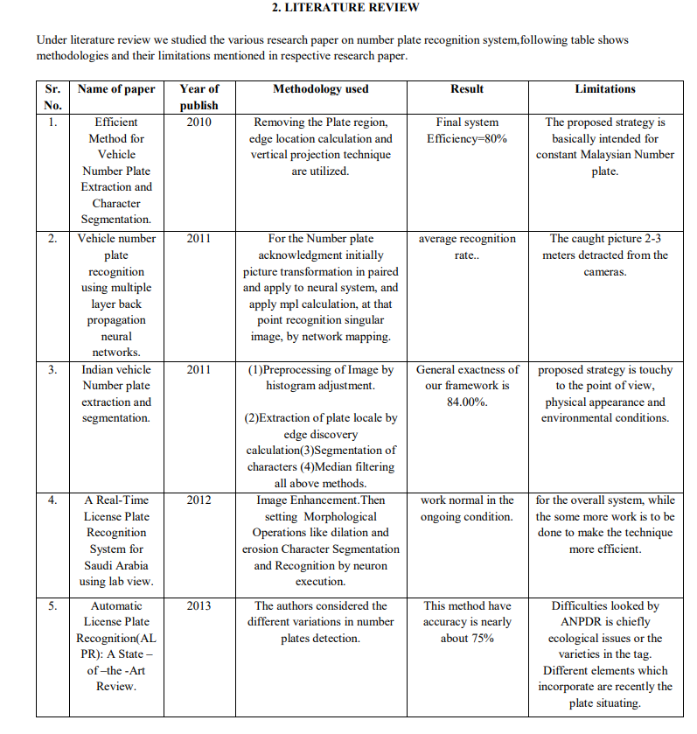

Table 2.1 Literature Review

Chunyu C introduced a strategy for acknowledgment of number plate from vehicle picture. This procedure is executed utilizing MATLAB and characters are perceived utilizing edge recognition division and pre preparing of picture

Peng H introduced a calculation named "Archive Picture Acknowledgment". DIR is best methodology which is utilized to discover most comparative format for input picture in an information base. The calculation is created based on worldwide coordinating of CBP

Chittode J created calculation which is applied on the vehicle leave frameworks to screen and oversee leaving administrations. Calculation is created based on morphological tasks and utilized for number plate acknowledgment. Optical character is utilized for the acknowledgment of characters in number plate.

Lekhana G.C built up an effective ongoing on-line Number plate acknowledgment framework. NPR calculation works in various advances initially picture procurement, utilizing combination of ghostly examination characters are sectioned and characters are perceived.

Paunwala C.N proposed a system which discovers return for money invested utilizing morphological preparing and directional division. The return on initial capital investment is the territory which incorporates the number plate from which alphanumeric characters are perceived. This technique is tried on various information bases which contain pictures.

Singh M built up a proficient methodology deals with opening and shutting of morphological tasks. Initially limitation of plate in picture has been done at that point slant adjustment is accomplished for division cycle of alphanumeric characters. Recognization is finished utilizing the layout coordinating.

Kranti S introduced a technique for number plate extraction named "Highlight based number plate confinement ". This approach for the most part bargains on two techniques edge recognition and window sifting strategy. The two techniques are utilized in this approach and give effective outcomes.

Ganapathy V built up a strategy for Malaysian vehicles. This technique is predominantly founded on Hough change and morphological examination and results extraction of number plate with 95% exactness.

Othman K utilized a methodology which is surface put together methodology and worked with respect to edge data for restriction and acknowledgment. Multi layer perceptron and neural organization are utilized for division of alphanumeric characters of tag.

**CHAPTER 03**

**EXISTING SYSTEM AND PROBLEM STATEMENT**

PC vision and character acknowledgment, calculations for tag acknowledgment assume a significant part in video examination of the number plate picture. Along these lines they structure the center modules in any ANPR framework. The framework for programmed vehicle tag acknowledgment incorporate

es a camera, a casing grabber, a PC, and hand crafted programming for picture handling, investigation and acknowledgment. Vehicle recognizable proof has been a functioning exploration for in the course of the most recent couple of years. Various investigates have been done to distinguish the kind of vehicle, for example, a vehicle, truck, bike or bike. Soble channel was utilized to deliver this issue to discover the edges of the vehicle which thus is applied to perceive the sort of vehicle.

**The Contourlet Transform and Support Vector Machine (SVM):**

They were utilized in to discover the model of the vehicle. They indicated mathematical outcomes on informational collection of around 70 pictures. Be that as it may, they didn't have any significant bearing the strategy to constant video transfer. In monocular pictures are utilized for vehicle acknowledgment. They applied vigilant edge recognition to distinguish the presence of vehicle and SVM to perceive the vehicle. In Greatest Normal Connection Tallness (MACH) channel and Log r-theta Planning strategies were applied to perceive the sort of vehicle independent of scale and pivot variety of vehicles. The MACH channel was utilized for recognition of focuses in jumbled climate. MACH was utilized to channel perceive the objective to direction invariance and they utilized log r-theta planning to make inplane pivot and scale invariance while acknowledgment .

**Optical Character Recognition (OCR):**

This method was utilized, which is a broadly utilized innovation which interprets filtered pictures of printed text into machine encoded text. Here, an OCR calculation dependent on feed-forward neural organization is being proposed where two non-covering genuine character picture informational collections are utilized for preparing and testing the proposed neural organization. The two non-covering picture informational indexes were utilized to imitate true situations where the neural organization will be exposed to Fake Neural Organizations (ANN) are generally utilized savvy figuring design for design acknowledgment. The most widely recognized utilized ANN is the multilayer feed-forward neural organization which has a basic interior engineering that can group contributions to a bunch of target classes.

Ordinarily, the works use highlights extraction and parallel pixels incentive to coordinate the contributions of neural organization individually, the previous one is the most well-known utilized technique for neural organization, which can accomplish great execution much under troublesome climate. Nonetheless, the element extraction typically needs complex calculation or different stages to extricate highlights. Comparative techniques are available which utilize additional methodology during the preparation stage or subsequent to getting the aftereffects of neural organization to deal with troublesome characters that have a place with the arrangements of uncertain characters. Extra preparing is utilized for the troublesome characters (for example I/1, B/8 and O/D) and in correlation of recognizing portions of questionable characters is performed. The measurable classifiers can be separated into two sub-classes: single stage classifier and multistage classifier.

In the work introduced character highlights are separated from the versatile cross section, and the whole location character string is taken as the object of study. This was tried utilizing Japanese Number Plates and the Help Vector Machine (SVM) mix utilizes the highlights to perceive numbers, Kana (Japanese content), and the series of characters that speak to the zone. The acknowledgment rates for numbers, Kana and series of characters are 99.5%, 98.6% and 97.8% separately. A two-stage crossover OCR framework is introduced to improve the acknowledgment rate. It right off the bat utilizes four factual sub classifiers to autonomously perceive the information character and afterward the outcomes are consolidated utilizing the Bayes' strategy Also, if the perceived character from the principal stage have a place with the arrangements of vague characters (for example I/1, B/8 and O/D), a primary stage is utilized for a further choice.

**Vehicle-License-Plate Recognition Based on Neural Networks:**

The creators gave the inventive methodology for Tag acknowledgment dependent on Neural Organization. To perceive the number plate the neural organization chip is utilized. made out of two modules video picture handling module with neural organization module utilizing balanced picture preparing calculation and organization characterization calculation. The chip incorporates picture sensor, CogniMem chip, interface circuit and PC observing module. The video from the picture sensor is shipped off video module of the CogniMem chip. The element vector is naturally produced by the chip from the locale of interest given by client. The acknowledgment is appeared on the PC .

Professionals: Fast of acknowledgment. The acknowledgment season of CM1K framework was 101µs, while the vast majority of the current innovations need millisecond preparing time. High dependability. The CM1K framework performs preferred in security over programming framework, on the grounds that the greater part of the circuit was incorporated in the FPGA, and the base equipment completed a lot of sum work of acknowledgment. Actually, the product framework is totally subject to the PC, so any postponement for the PC may make it misfortune a few plates.

Cons: Acknowledgment rate is less.

**A license plate recognition algorithm for Intelligent Transportation System applications**

In this procedure the creator gave another methodology for picture division. The tag acknowledgment framework as utilizations a calculation novel versatile picture division method (Sliding Concentric Windows-SCW) and associated segment examination related to a character acknowledgment Neural Organization. The calculation was tried with specific regular scene dim level vehicle pictures of various foundations and surrounding light. The camera focused inside the plate, while the point of sight and the separation from the vehicle changed by the condition if necessary. The character acknowledgment measure is finished by PNN (Probabilistic Neural Organization).

The SCW is utilized for the portraying the neighborhood abnormality in the picture utilizing picture measurements. It makes two windows for the pixel of the picture. In the event that the proportion of factual estimation in two windows more than edge set by the client, at that point the focal pixel of windows is considered as the Locale of Interest. It gives ideal outcome, if the proportion of concentric window is close to the proportion of the item is characterized.

Masters: The epic versatile procedure for division for example Sliding Concentric windows utilized for the finding the locale of Interest and for division the associated part examination is utilized. The OCR framework is a two layer Probabilistic Neural Organization (PNN) with geography, whose presentation for whole plate acknowledgment came to has been improved without any problem.

Cons: The significant downside in the proposed algorithmic succession spin around the differing light levels experienced during a 24 hour time frame and the impact those lighting changes have on the picture being sent to the OCR program just as because of the actual appearance of the plates.

**New Morphology-Based Method for Robust Iranian Car Plate Detection and Recognition:**

The creator has introduced another ongoing and hearty strategy for tag location and acknowledgment dependent on the morphology and format coordinating. Segregation of the picture is the principle period of the framework, from advanced picture clicked by camera in various conditions.

Initially the picture is preprocessed for additional acknowledgment, after that morphological administrator is applied for picture area. The morphological administrator depends on the shapes. Morphological cycle is utilized for character division. It eliminates all little associated components. At that point enlargement administrator is applied to isolate the character from one another. Also, segment checking is accomplished for character division. Character acknowledgment is finished with the assistance of layout coordinating cycle. For this picture relationship technique is utilized.

Experts: It gives better execution for tag confinement. It effectively finds the area of plate up to 97.3%.

Cons: If the picture quality isn't acceptable the framework get neglected to perceive the characters

**Automatic Vehicle Identification by Plate Recognition**

The creator presents another savvy and basic calculation is introduced for the tag acknowledgment. The LPR works in various parts: plate district extraction, character division and acknowledgment. The acknowledgment cycle is finished with the assistance of format coordinating. The plate is initially changed over into binarized picture then the spreading calculation is applied to discover the plate area. After this the morphological administrator is applied to get the area. At that point division is finished with the morphological capacity. The widening administrator is utilized for discrete the characters. Prior to the acknowledgment, the characters are standardized. Normaliztion is accomplished for refine characters into a square containing no void areas and afterward characters are found a way into equivalent size for layout coordinating. Cross relationship strategy is utilized for character acknowledgment.

Tollgates in India by and large utilize a simply visual arrangement of vehicle grouping. Anyway this makes a tremendous loss of income the organizations working the tollgates because of wild misbehaviors and disparities. To keep a tab on the administrators a few tollgates utilize a framework utilizing fiber optic sensors to consequently characterize a vehicle out of sight and count the outcomes with the manual sections. Anyway this framework is costly confounded and requires high support. We expect to consider the different frameworks that can be utilized to supplant such a framework with a less expensive and proficient other option

To keep a tab on the administrators a few tollgates utilize a framework utilizing fiber optic sensors to consequently group a vehicle out of sight and count the outcomes with the manual passages. Anyway this framework is costly convoluted and requires high upkeep. We expect to contemplate the different frameworks that can be utilized to supplant such a framework with a less expensive and productive other option. Anyway the social situation in India is essentially unique because of issues, for example, neediness, joblessness just as an extensively lower regard for rules. This makes it impractical to go for a totally programmed tollgate.

The business requires a programmed vehicle arrangement framework in India not to diminish or dispense with human mediation or work, yet to guarantee that human intercession doesn't bring about any monetary acts of neglect.

The business requires a framework that runs out of sight and just keeps a cross-mind the manual.As previously expressed, the framework utilizing fiber optics characteristically has countless issues separated from the primary worries of significant expense and upkeep. Albeit an IR shade framework decreases the expense fundamentally, it is still very costly and less expensive choices are wanted. As practically all the tollgates utilize cameras for security purposes, it was felt that the possibility of a framework utilizing IP cameras should be tried.

**CHAPTER 04**

**PROPOSED SYSTEM**

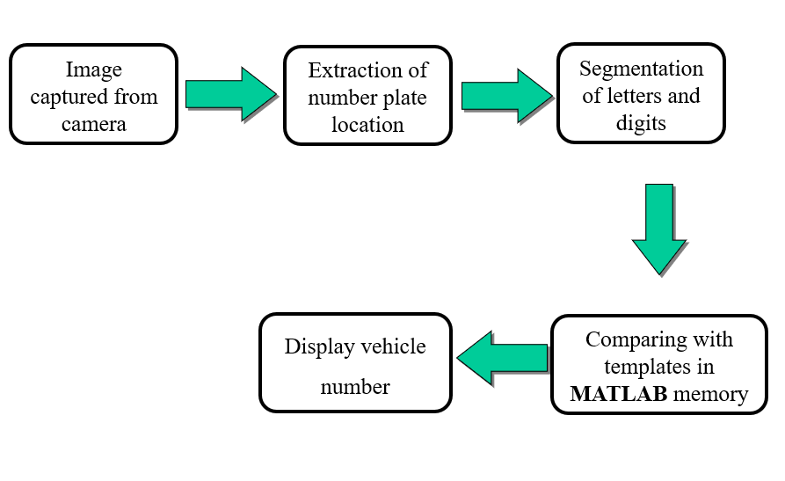

**Figure 4.1** Block digram

**Software used :** MATLAB 2016a (version 9.0)

**Algorithm :**

1. Call the twofold pictures of alphanumericals utilizing imread() order

2. Create a grid of letters in order and numbers and save at that point utilizing save(,) order.

3. Convert the info picture from RGB to grayscale utilizing rgb2gray() order.

4. Binarize it utilizing imbinarize() order.

5. Detect the edges in the picture utilizing edge() order.

6. Detect the area of number plate utilizing regionprops() and numel() orders

7. Crop the number plate utilizing imcrop()

8. Remove little obejects from parallel picture utilizing bewareopen() order.

9. Resize it with imresize() order

10. Compare the information picture with format pictures utilizing for circle

11. Obtain the yield.

**CHAPTER 05**

**PROJECT DESCRIPTION**

**Software specifications :** MATLAB 2016a

The name MATLAB represents lattice research center. MATLAB was composed initially to give simple admittance to grid programming created by the LINPACK (direct framework bundle) and EISPACK (Eigen framework bundle) projects. MATLAB is an elite language for specialized registering. It coordinates calculation, perception, and programming climate. MATLAB has numerous favorable circumstances contrasted with ordinary programming languages for tackling specialized issues. MATLAB is an intuitive framework whose essential information component is a cluster that doesn't need dimensioning. Explicit applications are gathered in bundles alluded to as tool compartment. There are tool stash for signal handling, emblematic calculation, control hypothesis, reenactment, enhancement, and a few different fields of applied science and designing.

**MATLAB's POWER OF COMPUTAIONAL MATHMATICS**

MATLAB is utilized in each aspect of computational arithmetic. Following are some ordinarily utilized numerical figurings where it is utilized most usually:

• Managing Frameworks and Exhibits

• 2-D and 3-D Plotting and designs

• Direct Polynomial math

• Arithmetical Conditions

• Non-direct Capacities

• Insights

• Information Investigation

• Analytics and Differential Conditions Mathematical Figurings

• Combination

• Changes

• Bend Fitting

• Different other uncommon capacities

**FEATURES OF MATLAB**

Following are the essential highlights of MATLAB

• It is an elevated level language for mathematical calculation, representation and application advancement.

• It likewise gives an intelligent climate to iterative investigation, plan and critical thinking.

• It gives immense library of numerical capacities for direct polynomial math, measurements, Fourier investigation, sifting, improvement, mathematical joining and settling normal differential conditions.

• It gives worked in designs to envisioning information and instruments for making custom plots.

• MATLAB's customizing interface gives improvement instruments for improving code quality, viability, and augmenting execution.

• It gives instruments to building applications with custom graphical interfaces.

• It gives capacities to coordinating MATLAB based calculations with outside applications and dialects, for example, C, Java, .NET and Microsoft Dominate.

**USES OF MATLAB** MATLAB is generally utilized as a computational device in science and designing incorporating the fields of physical science, science, math and all designing streams. It is utilized in a scope of uses including:

* signal preparing and Interchanges
* image and video Preparing
* control frameworks
* test and estimation
* computational account
* computational science

**UNDERTSANDING THE MATLAB ENVIRONMENT**

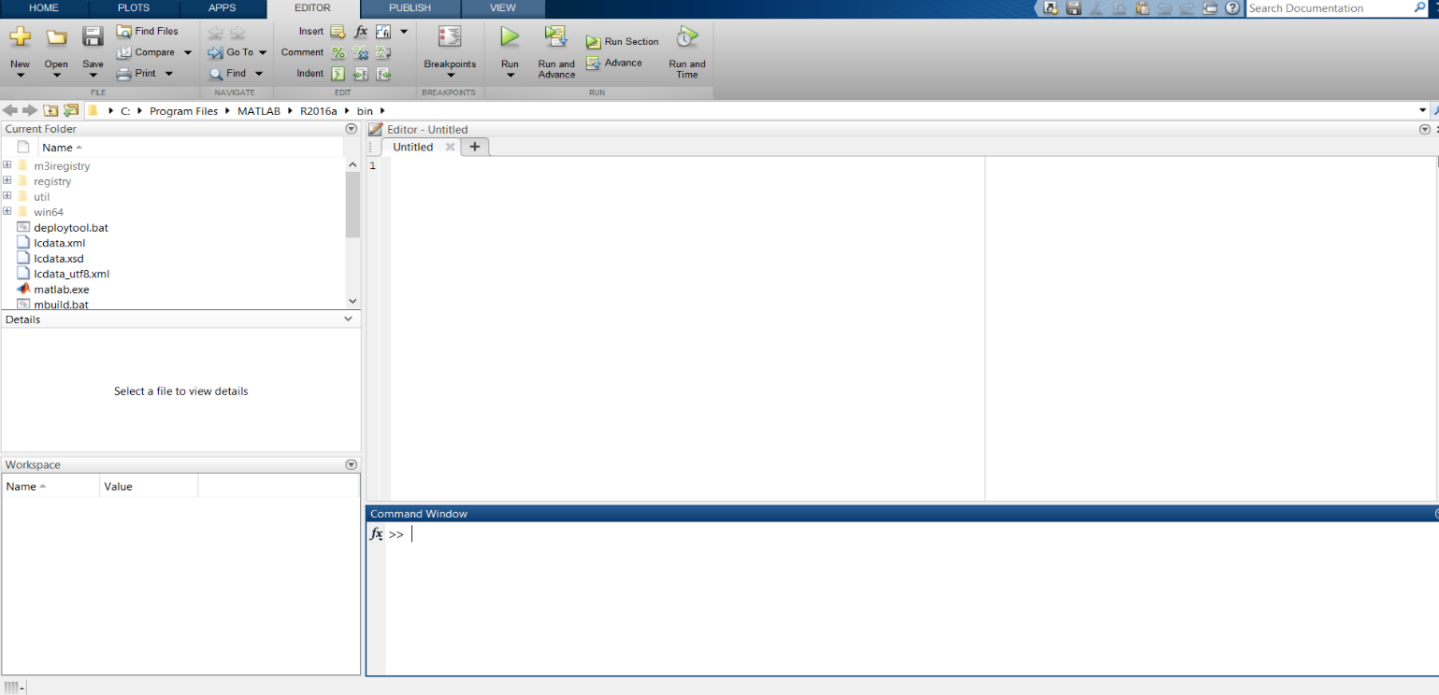MATLAB advancement IDE can be dispatched from the symbol made on the work area. The fundamental working window in MATLAB is known as the work area. At the point when MATLAB is begun, the work area shows up in its default design.

Fig 5.1 MATLAB desktop environment

**The desktop has the following panels:**

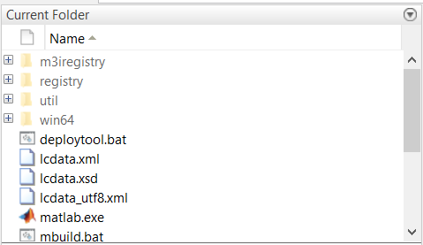 **Current Folder** - This panel allows you to access the project folders and files.

Fig 5.2 Current Folder

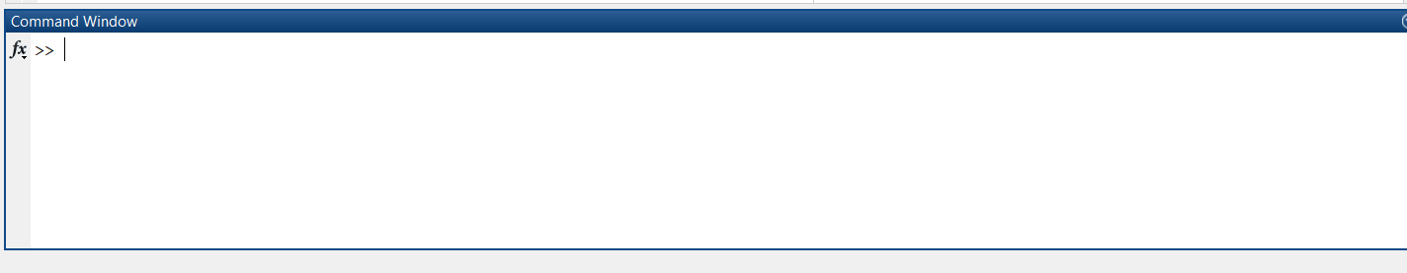**Command Window** - This is the main area where commands can be entered at the command line. It is indicated by the command prompt (>>).

Fig 5.3 Command Window

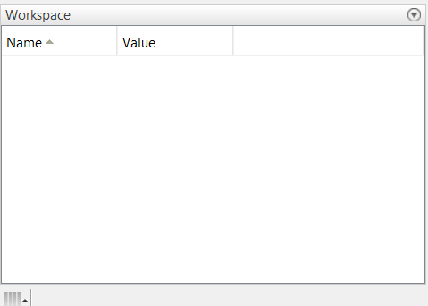 **Workspace** - The workspace shows all the variables created and/or imported from files.

Fig 5.4 Workspace

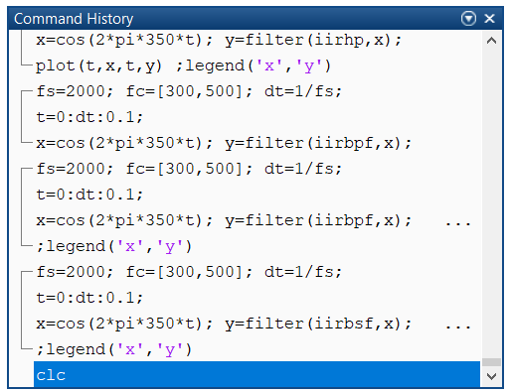**Command History** - This panel shows or rerun commands that are entered at the command line.

Fig 5.5 Command History

**COMMONLY USED OPERATORS AND SPATIAL CHARATERS**

MATLAB supports the following commonly used operators and special characters:

|  |  |
| --- | --- |
| **Operator** | **Purpose** |
| + | Plus; addition operator. |
| - | Minus, subtraction operator. |
| * | Scalar and matrix multiplication operator. |
| .* | Array and multiplication operator. |
| ^ | Scalar and matrix exponentiation operator. |
| .^ | Array exponentiation operator. |
| \ | Left-division operator. |
| / | Right-division operator. |
| .\ | Array left-division operator. |

**Table** 5.1 MATLAB used operators and special characters

**COMMANDS**

MATLAB is an interactive program for numerical computation and data visualization. You can enter a command by typing it at the MATLAB prompt '>>' on the Command Window.

**Command for managing a session**

MATLAB provides various commands for managing a session. The following table provides all

|  |  |
| --- | --- |
| **Command** | **Purpose** |
| Clc | Clear command window |
| Clear | Removes variables from memory |
| Exist | Checks for existence of file or variable. |
| Global | Declare variables to be global. |
| Help | Searches for help topics. |
| Look for | Searches help entries for a keyword. |
| Quit | Stops MATLAB. |
| Who | Lists current variable. |
| Whos | Lists current variables (Long Display). |

Table 5.2 commands for managing a session

**INPUT AND OUTPUT COMMAND**

MATLAB provides the following input and output related commands:

|  |  |
| --- | --- |
| **Command** | **Purpose** |
| Disp | Displays content for an array or string. |
| Fscanf | Read formatted data from a file. |
| Format | Control screen-display format. |
| Fprintf | Performs formatted write to screen or a file. |
| Input | Displays prompts and waits for input. |
| ; | Suppresses screen printing. |

**Table 5.3** input and output commands

**M FILES**

MATLAB allows writing two kinds of program files:

**Scripts:**

Content records are program documents with .m expansion. In these records, you compose arrangement of orders, which you need to execute together. Contents don't acknowledge inputs and don't restore any yields. They work on information in the workspace.

**Functions:**

Functions files are also program files with .m extension. Functions can accept inputs and return outputs. Internal variables are local to the function.

**Creating and Running Script File:**

To create scripts files, you need to use a text editor. You can open the MATLAB editor in two ways:

* Using the command prompt
* Using the IDE

DATA TYPES AVAILABLE IN MATLAB

MATLAB gives 15 key information types. Each information type stores information that is as a framework or cluster. The size of this framework or cluster is at least 0-by-0 and this can grow up to a network or exhibit of any size.

The following table shows the most commonly used data types in MATLAB:

|  |  |
| --- | --- |
| Datatype | Description |
| Int8 | 8-bit signed integer |
| Unit8 | 8-bit unsigned integer |
| Int16 | 16-bit signed integer |
| Unit16 | 16-bit unsigned integer |
| Int32 | 32-bit signed integer |
| unit32 | 32-bit unsigned integer |
| Int64 | 64-bit signed integer |
| Unit64 | 64-bit unsigned integer |
| Single | Single precision numerical data |
| Double | Double precision numerical data |
| Logical | Logical variables are 1 or 0 represent true &false respectively |
| Char | Character data (strings are stored as vector of characters) |
| Call array | Array of indexed calls, each capable of storing array of a  different dimension and datatype |
| Structure | C-like structure each structure having named fields capable of storing an array of a different dimension and datatype |
| Function handle | Pointer to a function |
| User classes | Object constructed from a user defined class |
| Java classes | Object constructed from a java class |

Table 5.4 Data types in MATLAB

The project includes numerous means beginning from plate extraction to layout coordinating. From the start, we perceive how number plate extraction occurs. The information picture goes through many picture preparing strategies which help in extricating number plate.

**1 .Converting RGB image into grayscale:**

The inputs to the system were the images of vehicles captured by a camera. RGB to gray-scale conversion is adopted, in order to facilitate the plate extraction, and increase the processing speed. Colour image (RGB) acquired by a digital camera is converted to gray-scale image using

I gray=0.114*R+0.587*G+0.299*B

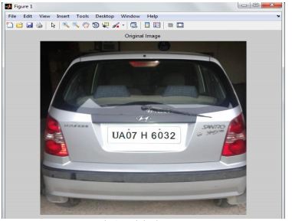

**Figure 5.6** RGB image

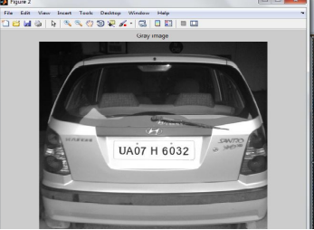

Figure 5.7 Grayscale image

**2.Detecting edges with the help of sobel edge detector :**

The fundamental advance in acknowledgment of vehicle number plate is to recognize the plate size. All in all number plates are fit as a fiddle, subsequently it is important to distinguish the edges of the rectangular plate. Numerical morphology is utilized to recognize the area of interese and Sobel administrator are utilized to figure the edge esteem, that identify high light areas with high edge greatness and high edge change.

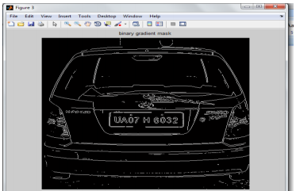

Figure 5.8Binarized image with sobel edge detection

**3.Converting it into a dilated image :**

The twofold angle veil shows lines of high difference in the picture. These lines don't exactly depict the framework of the object of interest. Contrasted with the first picture, holes in the lines are seen that encompasses the article in the slope cover. These straight hole vanishes if the Sobel picture is widened utilizing direct organizing components. Organizing component is spoken to as lattices, which is a quality of certain structure and highlights to quantify the state of a picture which is utilized to complete other picture handling activities. The twofold angle veil is widened

utilizing the vertical organizing component followed by the level organizing component.

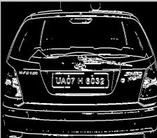

Figure 5.9 Dilated image

MATLAB tool stash give a capacity imfill (BW, "openings") that fills openings in the binarized picture. The enlarged slope veil shows the blueprint of the cell pleasantly, yet there are still openings in the inside of the cell. The arrangement of foundation pixels are known as opening that have not eliminated by filling the foundation from the edge of the picture. Figure 7 shows after evacuation of lower than 100 associated pixels. The enlarged inclination cover shows the blueprint of the locale pleasantly, yet there are still openings in the inside of the area, to fill these

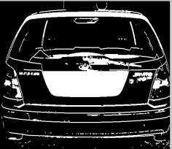

Figure 5.10 Filled image

**4.Remove connected objects on border :**

The area of interest has been effectively sectioned, however it isn't the lone item that has been found. Any items that are associated with the outskirt of the picture can be eliminated utilizing the imclearborder MATLAB work. The network in the capacity was set to 4 or 8 to eliminate slanting associations and fill the opening to find the plate locale. In the wake of eliminating the lower pixel parts real plate district is recognized.

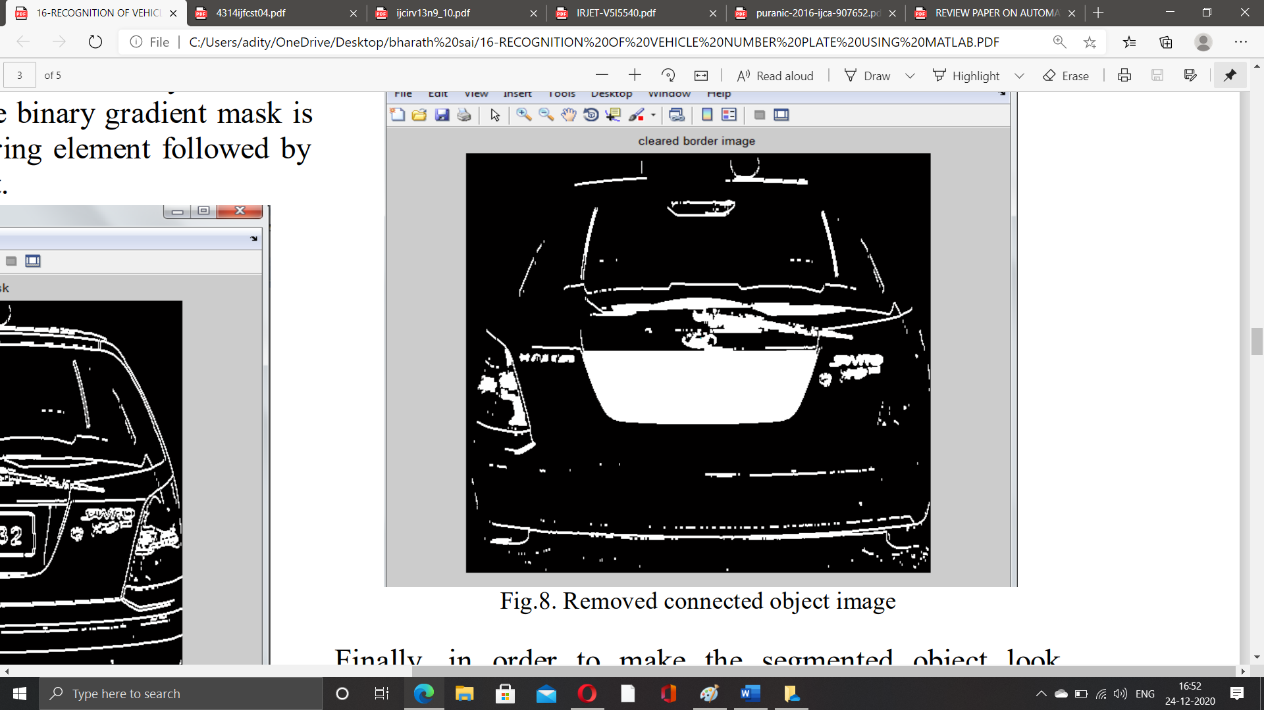

Figure 5.11 Image with connected borders

Finally, in order to make the segmented object look natural, the image is eroded twice with one of the diamond, disk and line structuring element. This helps in extraction of number plate area of the vehicle

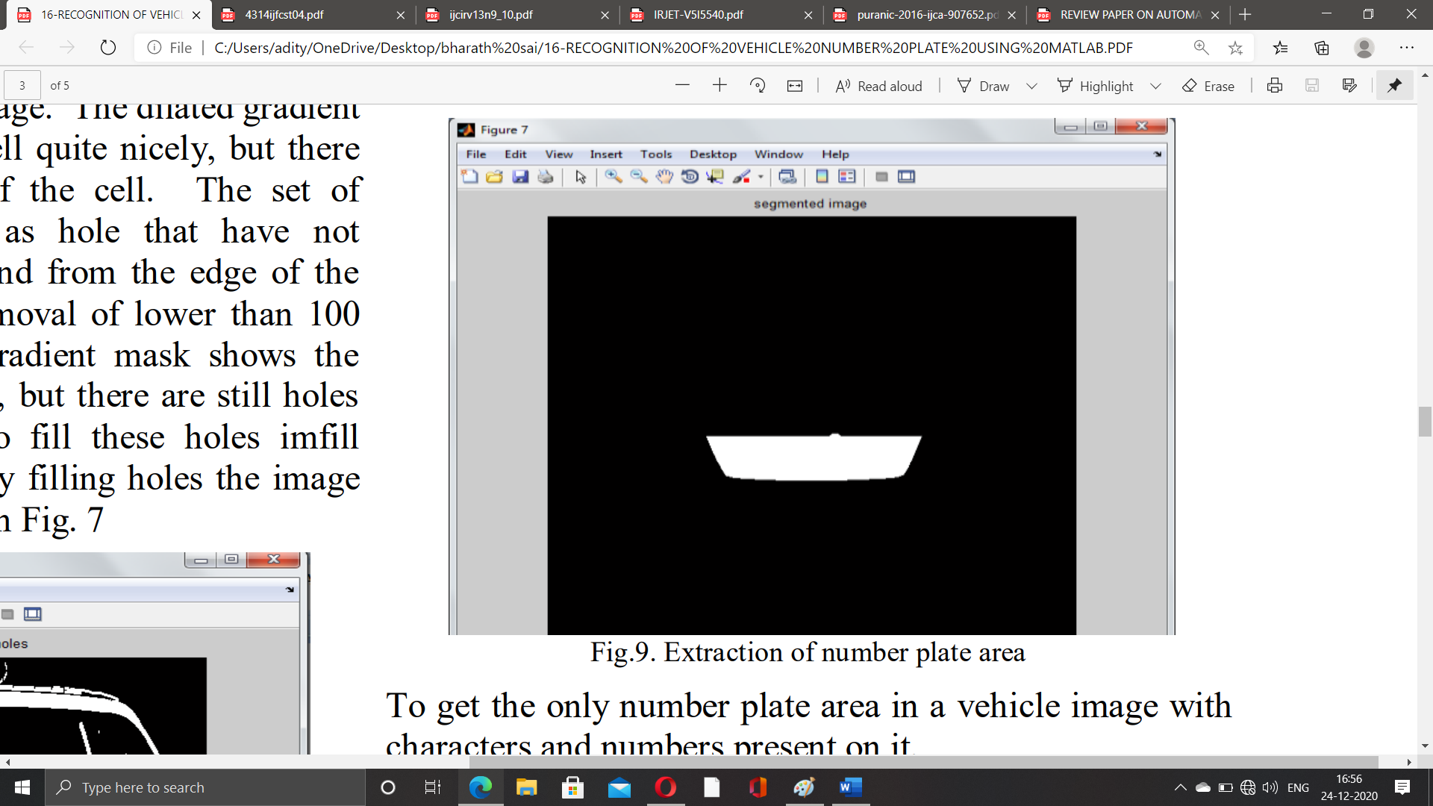

Figure 5.12 extracted number plate region

To get the only number plate area in a vehicle image with characters and numbers present on it, the segmented image is multiplied with gray scale image.

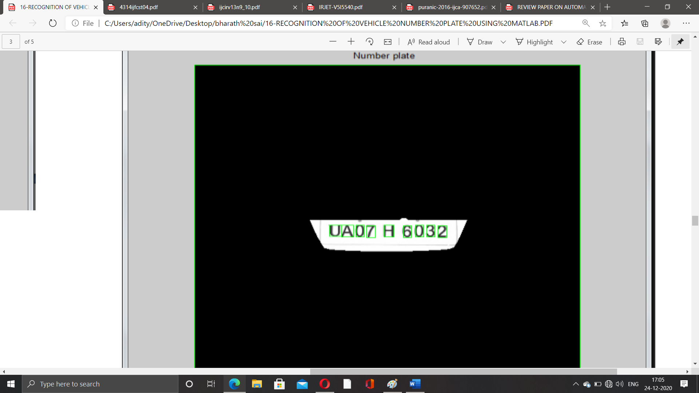

Figure 5.13 Number plate

**Character segmentation:**

Division is quite possibly the main cycles in the number plate acknowledgment, since all further advances depend on it. In the event that the division fizzles, a character can be inappropriately separated into two pieces, or two characters. A definitive arrangement on this issue is to utilize jumping box procedure. The bouncing box is utilized to gauge the properties of the picture area. When a bouncing box made over each character and numbers introduced on number plate, each character and number is independent out for acknowledgment of number plate.

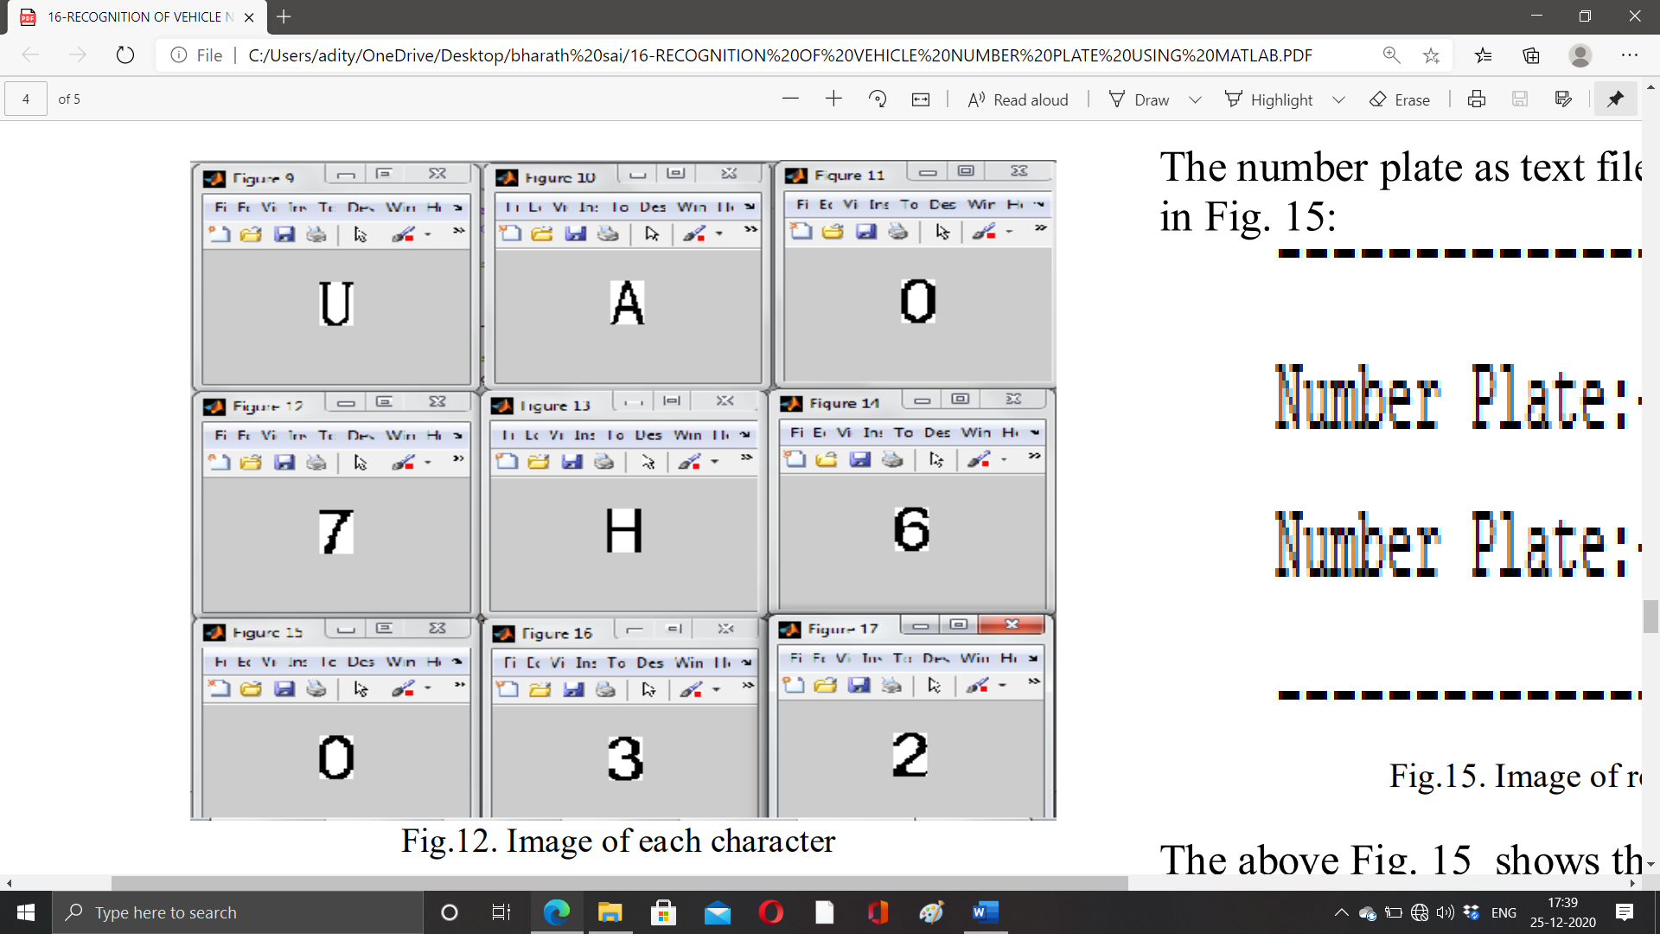

Figure 5.14 Segmented images

**Character recognition & display the result:**

It is utilized with the end goal of change of pictures of text into characters. Number plate acknowledgment is currently used to think about the every individual character against the total alphanumeric information base utilizing format coordinating. The coordinating cycle moves the format picture to all potential situations in a bigger source picture and processes a mathematical record that demonstrates how well the layout coordinates the picture in that position. Coordinating is done on a pixel by pixel premise. The format is of size 42 × 24 as appeared in Fig.13.Since the layout size is fixed, it prompts precise acknowledgment.

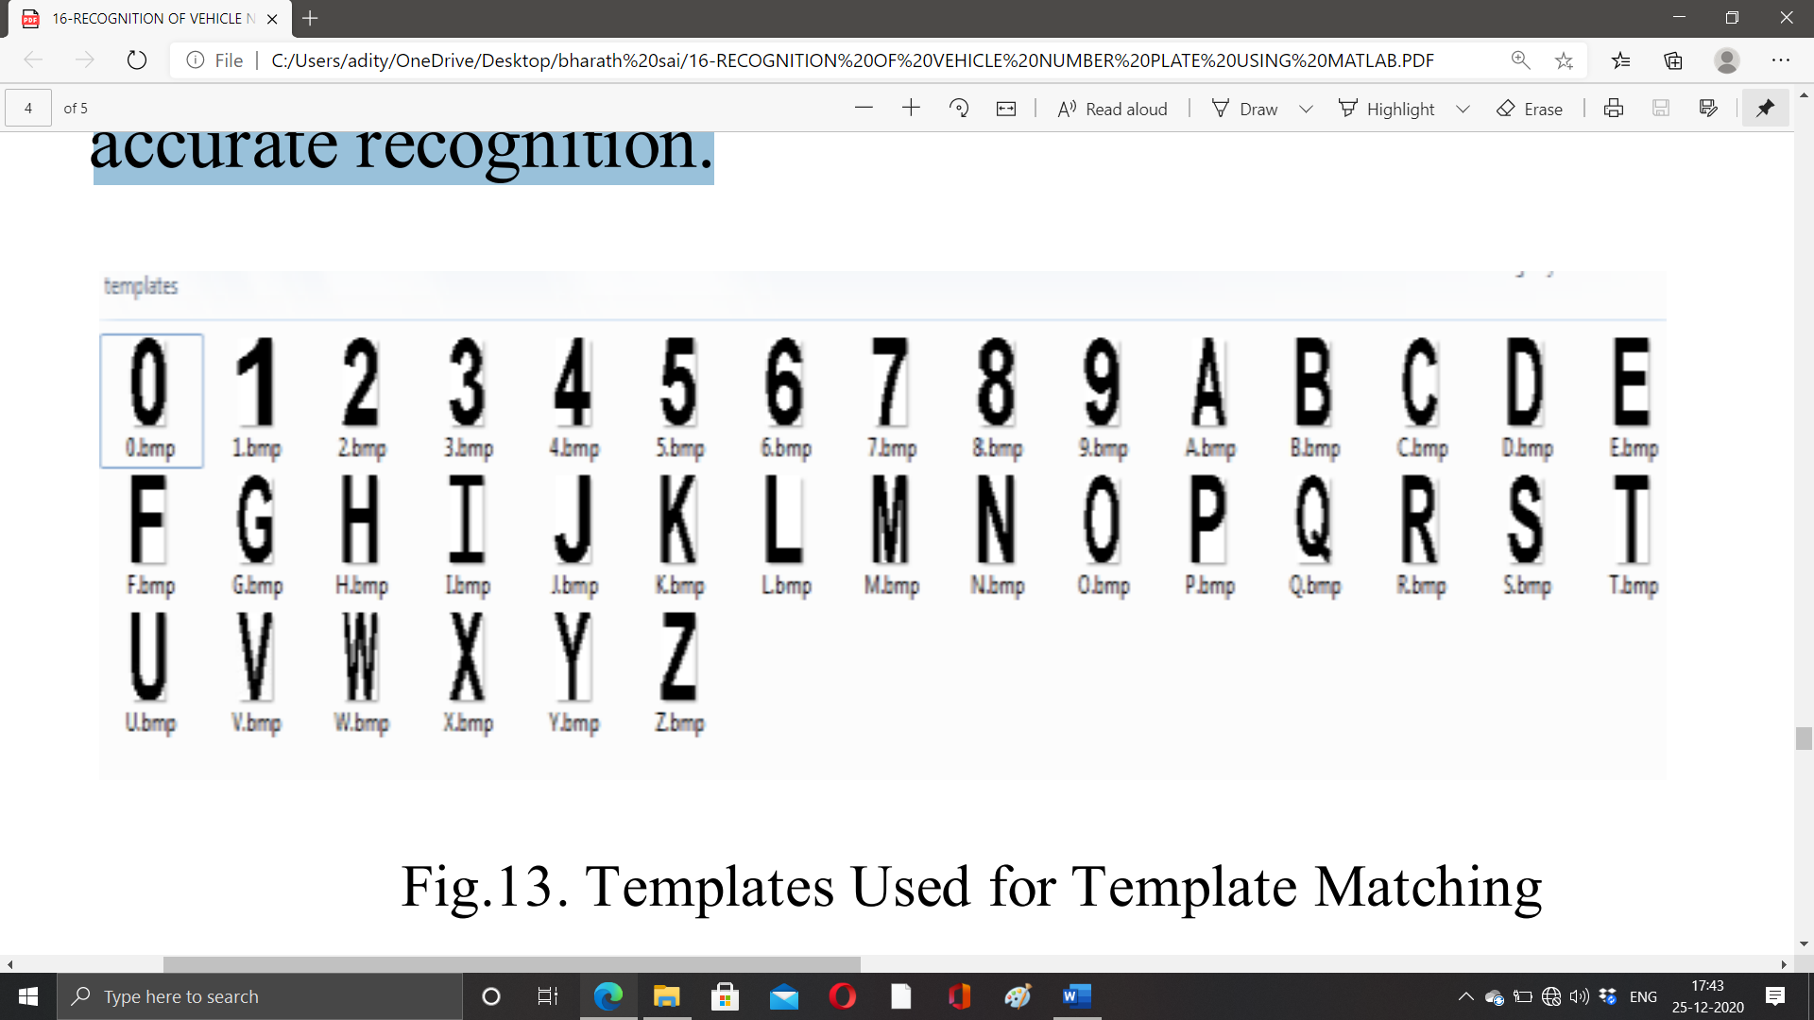

Figure 5.15 Binary images of alpha numericals

**CHAPTER 06**

**RESULT AND DISCUSSION**

The result of the MATLAB system can be viewed as

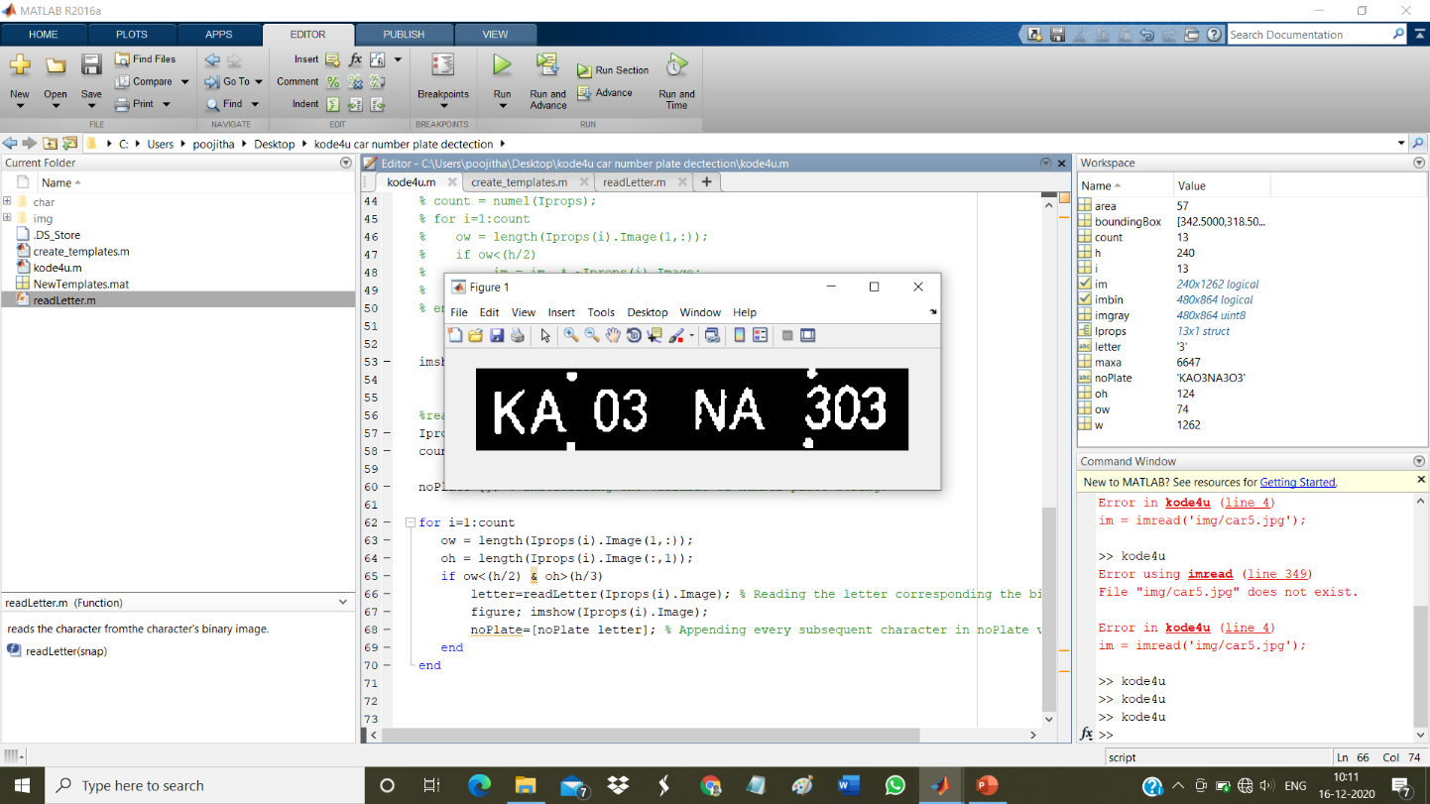

Figure 6.1 Result

The vehicle should remain fixed while snapping the photo and the image is gotten from settled guide equal toward the earth. We went up against some inappropriate ID either due to the framework, that couldn't remove the number plate from grayscale of the picture taken inappropriately or due to luminance conditions and hazy foundation. Number plate extraction needs an incredible level of high precision when going after the pictures of occupied roads or stopping territories.

**CHAPTER 07**

**CONCLUSION AND FUTURE SCOPE**

In this framework , an application programming is intended for the location of number plate of vehicles utilizing their number plate. From the start plate area is extricated utilizing morphological activity at that point isolated the plate characters exclusively by division. At long last layout coordinating is applied with the utilization of relationship for acknowledgment of plate characters.

Some of potential troubles:

1. Broken number plate.

2. Hazy pictures.

3. Number plate not inside the legitimate determination.

4. Low goal of the characters.

5. Helpless support of the vehicle plate. Comparability between specific characters, specifically, O and D; 5 and S; 8 and B, E; O and 0, and so forth

In NPR framework, the image of vehicle number plate is taken with the picture catching framework and the permit number of the vehicle is seen with the objective that the information and data of the vehicle proprietor can be gotten. In our paper, we have played out a strategy in which the image of the vehicle plate is taken. By then, the commotion diminishment is performed on it to give indications of improvement come to fruition. After this, division and distinguishing proof of characters are finished utilizing the layout coordinating strategy. Regardless, the framework can be used only for parallel pictures and not for RGB pictures. As a result of moving credits of the number plate, extra examination is so far needed here.

Unmistakable sifting methodology can be familiar with the diminishing of clamor to a more significant degree, so the picture handling can be more profitable. In future, the acknowledgment of number plate should be conceivable from the video preparing also.

1. Parking :- The NPR is utilized to consequently enter prepaid individuals and compute stopping expense for nonmembers.
2. Access control :- An entryway consequently opens for approved individuals in a made sure about region, hence supplanting or helping the safety officer.
3. Tolling :- The vehicle number is utilized to ascertain the movement expense in an expressway or used to twofold check the ticket.
4. Border Security :- The vehicle number is enrolled in the passage or ways out to the nation and used to screen the outskirt intersections.
5. Traffic Light :- The vehicles can be coordinated to various paths as indicated by their entrance licenses. The framework lessens the gridlocks and number of chaperons.
6. Airport parking :- to diminish ticket fakes or missteps, the NPR unit is utilized to catch.

the number plate and picture of the vehicle

**REFERENCES**

[1] R.Radha1 and C.P.Sumathi2, “A Novel approach to extract text from license plate of vehicle”, Signal & Image Processing : An International Journal (SIPIJ) Vol.3, No.4, August 2012

[2] Shen Zheng Wang & His-Jian Lee “Detection and Recognition of License Plate Characters with Different Appearances”,IEEE Intelligent Transportation Systems, Proceedings 2003 , vol.2 , Page(s): 979 – 984.

[3] Humayun Karim Sulehria, Ye Zhang, Danish Irfan, Atif Karim Sulehria, “ Vehicle Number Plate Recognition Using Mathematical Morphology and Neural Networks”, WSEAS TRANSACTIONS on COMPUTERS, Volume 7,ISSN: 1109-2750, Issue 6, June 2008.

[4] Dr. P.K.Suri, Dr. Ekta Walia, Er. Amit Verma,” Vehicle Number Plate Detection using Sobel Edge Detection Technique”, International Journal of Computer Science and Technology, ISSN : 2229 – 4333, IJCST Vol. 1, Issue 2, December 2010.

[5] Kumar Parasuraman and P.Vasantha Kumar, “ An Efficient Method for Indian Vehicle License Plate Extraction and Character Segmentation”, IEEE International Conference on Computational Intelligence and Computing Research,2010.

[6] Lekhana G.C, R.Srikantaswamy ,“Real time license plate recognition system”, International Journal of Advanced Technology & Engineering Research (IJATER), National Conference on Emerging Trends in Technology (NCETTech) ISSN, Volume 2, Issue 4, ISSN No: 2250-3536, July 2012.